Software Requirements Specification (SRS)

for Digital Payment Wallet

Viraj Kisan Daule

­ BL.EN.U4CSE22162

**I Introduction**

**1) Purpose:**

The Digital Payment Wallet aims to provide a user-friendly platform for sending and receiving money, paying bills conveniently and securely storing funds. This system is a solution that bridges customers, merchants, and banking institutions through seamless and secure financial transactions.

**2) Stakeholders:**

* **Customers:** Individuals who will use the wallet to perform peer-to-peer transactions, bill payments, or QR code based transactions.
* **Merchants:** Businesses accepting payments through the wallet.
* **Banking Institutions:** Enabling backend processes like UPI integrations and following RBI security regulations.

**II Overall Description**

**1) System Overview:**

Numerous payment methods, including UPI, credit/debit cards, and net banking, can be integrated with the system. Users will have a variety of options for storing, transferring, and paying money, including:

* Credit/Debit Cards
* UPI (Unified Payments Interface)
* QR Code Payments
* Net Banking

The system will maintain an intuitive dashboard displaying real-time balance, transaction history, and customized notifications. Additionally, users will have access to in-app customer support for assistance.

**2) Key Features:**

The wallet will offer the following features:

**Secure Wallet Storage:** Users can store money in the wallet and use it for transactions.

**Peer-to-Peer(P2P) Transfers:** Instant money transfers between wallet users.

**QR Code Payments**: Scan and pay at merchant outlets or transfer funds to other users.

**Bill Payments**: Pay your utility bills, including those for gas, water, electricity, and mobile recharges.

**Transaction Tracking**: Users can view, filter, and download transaction history.

**Multi-Layer Security**: Two-factor authentication (2FA), biometric authentication, and fraud detection mechanisms.

**3) Regulatory Compliance:**

The system would adhere to international security standards and Reserve Bank of India (RBI) regulations, including:

• PCI-DSS (Payment Card Industry Data Security Standard) for card usage.  
• Secure payment gateways and data encryption to safeguard user data.  
• KYC (Know Your Customer) and AML (Anti-Money Laundering) regulations to avoid fraud.

**III Functional Requirements**

**1) User Account Management:**

* Users must register using a mobile number and verify via OTP (One-Time Password).
* Users can update personal details, such as name, email, and linked bank accounts.
* Forgot password functionality via OTP and email verification.
* Secure login using multi-factor authentication.

**2) Wallet Transactions:**

* Users can add money to their wallets via bank transfers, UPI, credit/debit cards, and net banking.
* Users can withdraw money from the wallet to their linked bank accounts.
* The system should ensure real-time processing and verification of transactions.
* Transaction failure handling with automatic refunds in case of issues.

**3) Payment Features:**

* Peer-to-peer (P2P) transactions between users.
* QR code scanning for instant payments to merchants.
* Bill payment options for utilities, mobile recharges, and subscriptions.
* Push notifications and SMS alerts for successful and failed transactions.

**4) Security Features:**

* Two-factor authentication (2FA) using OTP and biometric login.
* Encryption of stored and transmitted financial data.
* AI-driven fraud detection to monitor and prevent suspicious activities.
* Secure session management with automatic logout after inactivity.

**IV Non-Functional Requirements:**

**1) Performance:**

* To provide a seamless user experience, transactions must be completed in less than two seconds.
* The system should be capable of handling several concurrent users and many hundreds of transactions per second.
* Scalability features should allow system expansion as user demand grows.

**2) Security and Compliance:**

* Multi-layer authentication, including **password, OTP, PIN, and biometric security**.
* End-to-end encryption for data security and compliance with **PCI-DSS** standards.
* Adherence to **GDPR (General Data Protection Regulation)** and **RBI guidelines** for data privacy.

**3) Usability and Accessibility:**

* The system should provide an intuitive and easy-to-use interface for all age groups.
* Support for multiple languages and regional customization.
* Accessibility features for users with disabilities, including voice assistance and screen reader compatibility.
* Minimal learning curve for users with no prior experience in digital wallets.

**V Use Case Diagrams**

**1) Adding Money to Wallet:**

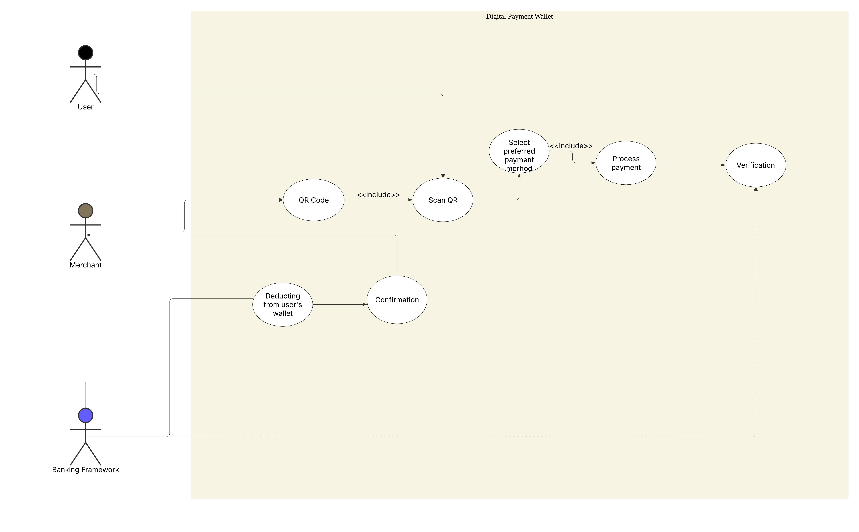

**2) Making a QR Code Payments:**

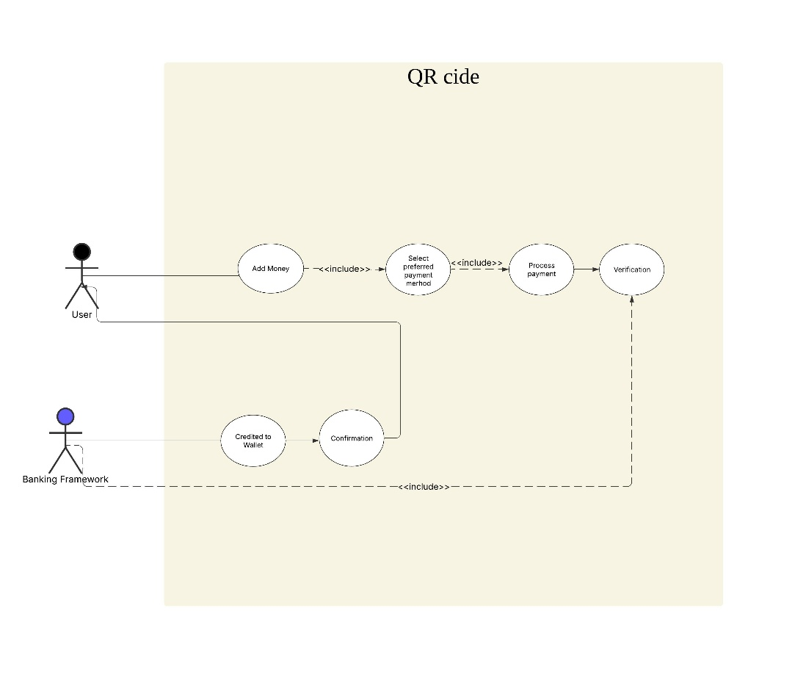

**VI Output**

The final **Software Requirements Specification (SRS) document** will be delivered in **PDF/DOCX** format. The document will provide all necessary details, including system functionalities, security considerations, and compliance guidelines, to facilitate seamless implementation and deployment.